

ECONOMICS

Practice SAC 2.1.2.2 – Budgetary and Monetary Policy

UNIT 2 - OUTCOME 2

You will have 80 minutes to complete this task.

The SAC is a Structured Questions Test

The total SAC is worth 10% of your Unit 1 grade.

Conditions and restrictions
- Students are permitted to bring into the room for this task: pens, pencils, highlighters, erasers, sharpeners and rulers
- Students are NOT permitted to bring into the room for this task: blank sheets of paper and/or white out liquid/tape.

Materials supplied
- Question and answer book of 12 pages

Instructions
- Print your name in the space provided on the top of the front page.
- All written responses must be in English.

Student name ____________________________________________

Grade/Score: ____/___30 Satisfactory Completion? S/N: ______
(Provisional)
--------------------------------------------------------------------------------------
Assessment Criteria
This assessment task was developed using the Outcome 1 key knowledge and skills in Unit 2 VCE Economics:
Key knowledge

• government economic policy responses designed to influence the rate of economic growth: budgetary policy and monetary policy

Key skills
• define key economic concepts and terms and use them appropriately
• access and synthesise information gathered from a range of sources and draw conclusions
• identify trends, patterns, similarities and differences in economic data and other information
• gather, interpret and analyse statistical and graphical data
• evaluate the potential costs and benefits associated with economic activity.

SECTION A – Multiple Choice
Instructions for Section A
Answer all questions.
Choose the response that is correct or that best answers the question.
A correct answer scores 1, an incorrect answer scores 0.
A mark will not be awarded if more than one response is chosen for a question.

Question 1

If the RBA changes the cash rate when the economy is growing very rapidly, the monetary policy stance is said to become more:
A. Expansionary or accommodative
B. Neutral
C. More restrictive or contractionary
D. unclear

Question 2
Which of the following events, or combination events, may result in the Reserve Bank of Australia (RBA) adopting a more expansionary monetary policy stance?
A. an increase in the world oil price over two consecutive periods
B. a decrease in the growth of both credit and household debt to income ratio, combined with the rapid appreciation of the Australian dollar
C. an increase in the official Australian Bureau of Statistics (ABS) unemployment rate and evidence of a higher level of labour force under-utilisation
D. a decrease in consumer confidence and aggregate demand, accompanied by renewed concerns about declining rates of economic growth in the economies of Australia’s major trading partners

Question 3
Which one of the following discretionary budgetary policy initiatives is unlikely to increase aggregate demand?
A. A reduction in personal income taxation
B. An increase in spending on education to improve literacy
C. The construction of the East-West Link
D. An increase in company taxation

Question 4
Australia’s GDP growth has slumped from 3.1% to 1.8% over the past two years. The likely effect of the change in GDP growth on discretionary stabilisers and public debt is:

A. Government will increase taxes and tighten welfare criteria to reduce transfer payment expenditure and public debt will fall
B. Government cut taxes, and invest in more infrastructure spending and public debt will rise
C. Government will increase taxes and tighten welfare criteria to reduce transfer payment expenditure and public debt will rise
D. Government cut taxes, and invest in more infrastructure spending and public debt will rise

Question 5
Which one of the following is not regarded as an indirect tax?
A. Company tax
B. The Goods and Services Tax (GST)
C. Excise tax on tobacco
D. Fringe Benefit Tax (FBT)

SECTION B – Written responses
Instructions for Section B
Answer all questions in the spaces provided.

Question 1 (11 marks)
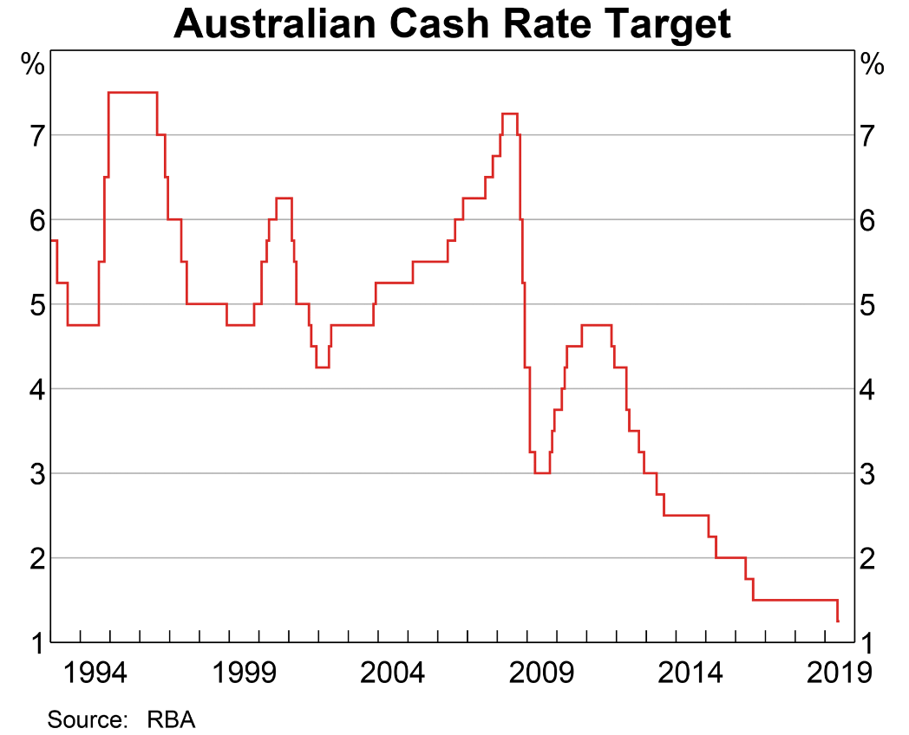
At its meeting today, the Board decided to lower the cash rate by 25 basis points to 1.00 per cent. This follows a similar reduction at the Board's June meeting. This easing of monetary policy will support employment growth and provide greater confidence that inflation will be consistent with the medium-term target.
Source: Philip Lowe, RBA governor, July monetary policy meeting

a. Define the following terms
4 marks
i. monetary policy.

ii. budgetary policy.

b. Outline the role of the RBA with respect to monetary policy as outlined in its charter.
2 marks

c. Using the chart above, describe the change in monetary policy stance since January 2017.

2 marks

d. Explain the focus of monetary policy setting over the past two years as a result of changes in unemployment, GDP growth and inflation.
3 marks

Question 2 (14 marks)
Refer to the 2019/20 Budget Overview (extract) and answer the following questions:
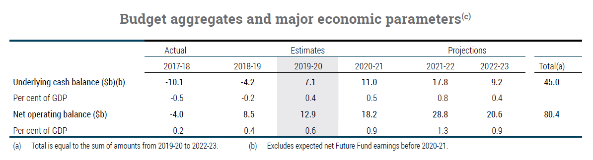
a. Comparing the underlying cash balance estimates in 2019–2020 with actual budget outcome for 2018–2019, describe the change in the stance of budgetary policy over the last two years.
(2 marks)

b. Explain how the Australian Government could utilise one discretionary initiative as part of the 2018-19 and one discretionary initiative 2019-20 Budget to achieve:

- real GDP growth
- Employment opportunities
6 marks

c. Assume that the real GDP and unemployment data relates to Australia over the past two years.
Year | GDP  (%) | Unemployment  (%)
1 | 3.1 | 5.1
2 | 5.5 | 2.9

Explain how these economic indicators are likely to alter Reserve Bank of Australia’s monetary policy stance. Explain how this should influence Aggregate Demand and the impact this may have on:
- real GDP growth and
- employment opportunities.
6 marks

Extra writing space
(clearly label all responses)

